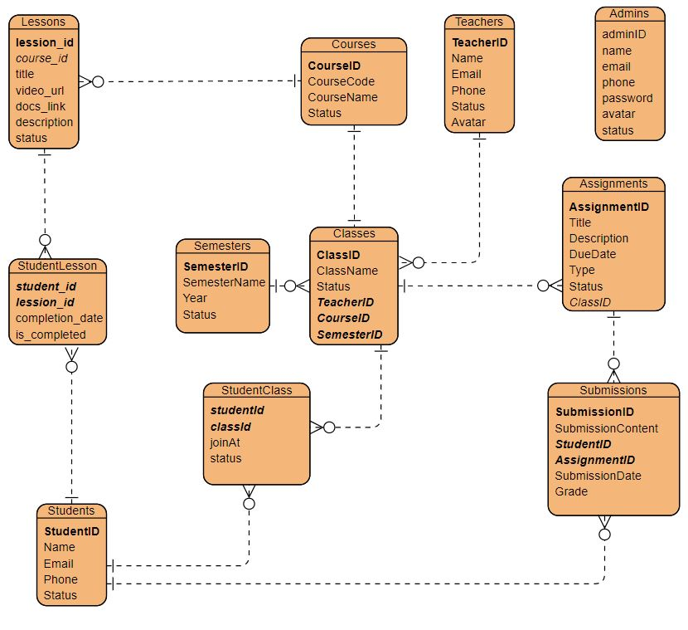
Cấu trúc JSP của tôi
- admin
  - …
  - lession
    - lession-form.jsp
    - list.jsp
- authen
    - login.jsp
- common
- commonAdmin
- commonStudent
- commonTeacher
- dashboard
- homepage
- student
- teacher

